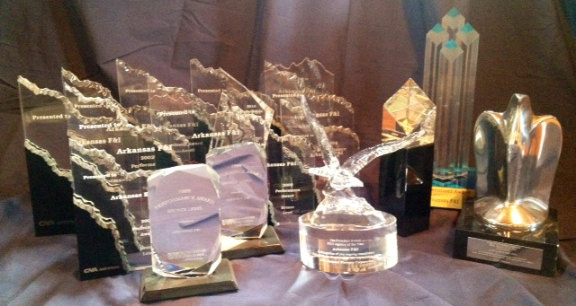
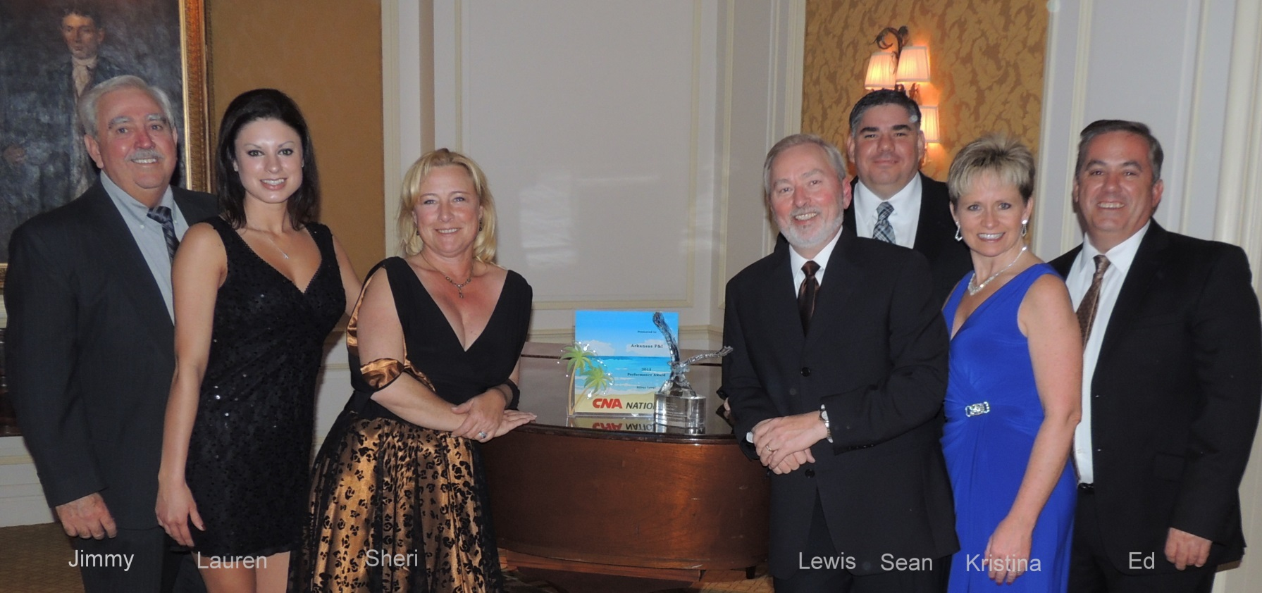

Three Great Names for Arkansas Auto Dealers

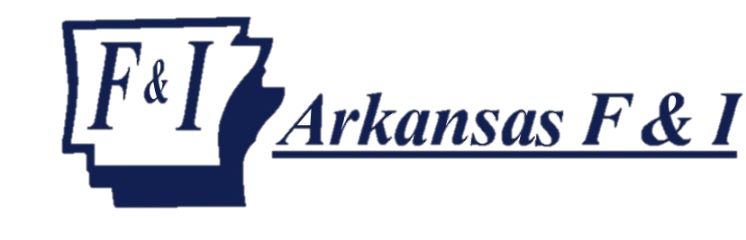

GREAT F&I PRODUCTS PROVIDED WITH AWARD-WINNING SERVICE OF ARKANSAS F&I
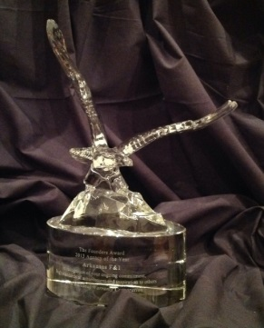
Arkansas F&I has won numerous national awards based on our partnership with successful dealerships. We want to thank the Arkansas F&I family of dealers for helping us to achieve the 2013 Agency of the Year Award, presented by CNA National Warranty Corporation. This is the most prestigious award available to agencies, and we have now received this recognition twice.
For those dealers who have not experienced the benefits of partnering with Arkansas F&I, contact us now. You will be amazed by the customer service and long term F&I profitability to your dealership!

Products and services offered
Incredible F&I Training  Menu training  Compliance training  F&I Income development | Service contracts  GAP  Identity Theft Restoration  Credit Insurance  Appearance protection | Vehicle Theft Protection  Participating Programs for dealers of any size  And Now, Dealer Owned Insurance Agencies

Serving Arkansas Auto Dealers since 1984
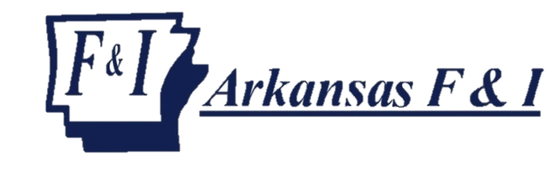 | Office: 800-489-4108  Fax: 501-865-3782  Email: lewis@arkansasfi.com  www.arkansasfi.com

